

MONTHLY REPORT

JANUARY 2023

HRA

**Managed Services**



Objective

Below report shows the comprehensive operation report for the ADDA tenant AD_HRA. The Report consists of Cloud Resource Utilization, Network Bandwidth Utilization, Alarm and Tickets handled by the Managed Services Team for Month 01 of 2023.

# Cloud Resource Utilization - HRA

|  |  |
| --- | --- |
| G42 Cloud Services | Current  Resource Count |
| Elastic Cloud Server (ECS) - PROD | 3 |
| Elastic Cloud Server (ECS) - STG | 10 |
| Elastic Cloud Server (ECS) - DEV | 2 |
| Elastic Cloud Server (ECS) - MGMT | 2 |
| Elastic Volume Service (EVS) – PROD | 17 |
| Elastic Volume Service (EVS) – STG | 19 |
| Elastic Volume Service (EVS) – Dev | 2 |
| Elastic Volume Service (EVS) - MGMT | 2 |
| Elastic Load Balancer (ELB) – PROD / STG / DEV | 5 |
| Virtual Private Cloud (VPC) - PROD / STG / DEV / RnD / MGMT | 9 |
| Cloud Container Engine (CCE) Nodes - PROD | 3 |
| Cloud Container Engine (CCE) Nodes - STG | 3 |
| Relational Database Service (RDS) - PROD | 1 |
| Relational Database Service (RDS) - STG | 7 |
| Relational Database Service (RDS) - DEV | 1 |
| Data Lake Insight (DLI) – Databases - PROD | 10 |
| Data Lake Insight (DLI) – Databases - STG | 11 |
| Data Lake Insight (DLI) – Databases - DEV | 9 |
| Data Lake Insight (DLI) – Databases - MGMT | 2 |
| Data Lake Insight (DLI) – Databases - RnD | 2 |
| Simple Message Notification (SMN) | 15 |
| Total Services | 130 |

# On-Boarded Users

|  |  |  |
| --- | --- | --- |
| IAM Users | | User Count |
| Enabled |  | 17 |
| Disabled |  | 1 |
| Total |  | **18** |



Total number of HRA cloud IAM user count is 17, there are 18 active users and 1 Disabled. User with naming {HRA_Name} were counted.

# Resource Usage

## ECS CPU Usage

**ECS CPU Usage Production**

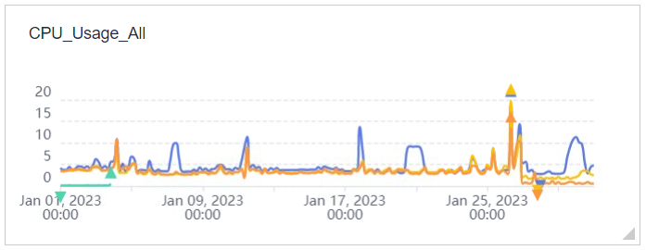

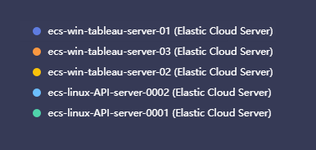



Production ECS CPU usage is below 20% and there is no heavy CPU usage in any of the servers.

There is a spike on Jan 26th which is a normal behavior and that is settled down after sometime.

## ECS RAM usage

**ECS RAM Usage Production**

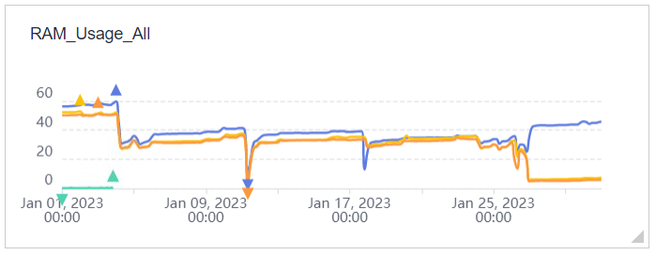





RAM usage in production declined after Jan 4 and stabilized thereafter, it is average at 40% Utilization. Resource utilization is effective from the infrastructure perspective.

## RDS CPU and Memory Usage

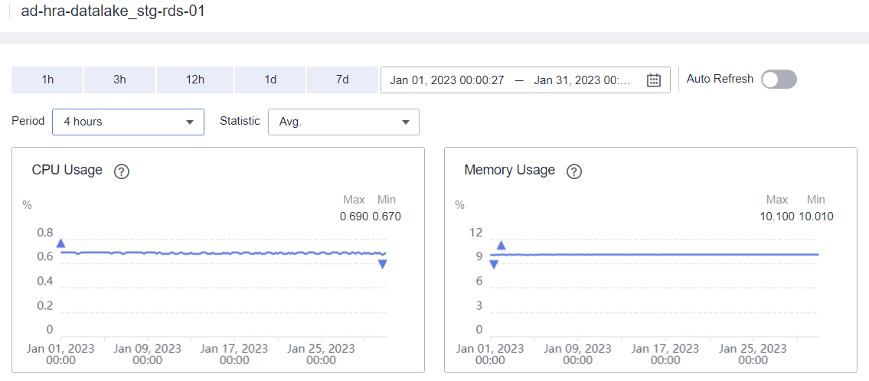

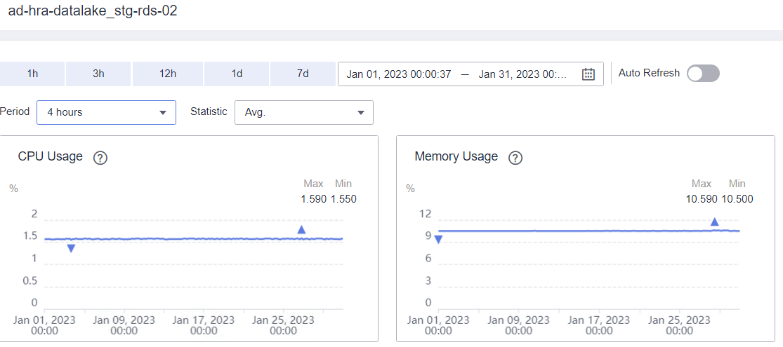

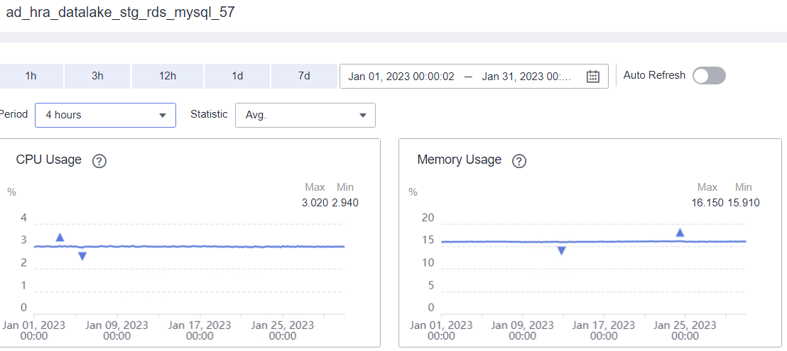



Staging RDS resource utilization is normal and used effectively.

RDS DataLake Production

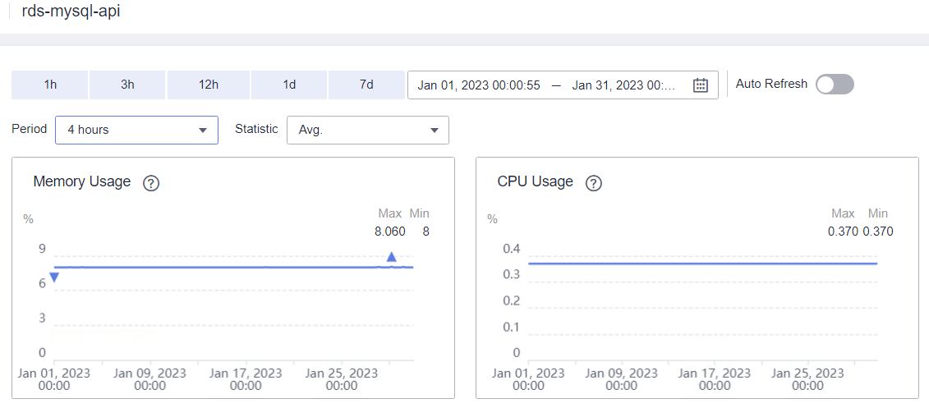



Production RDS resource utilization is normal and used effectively.

Staging CCE Cluster

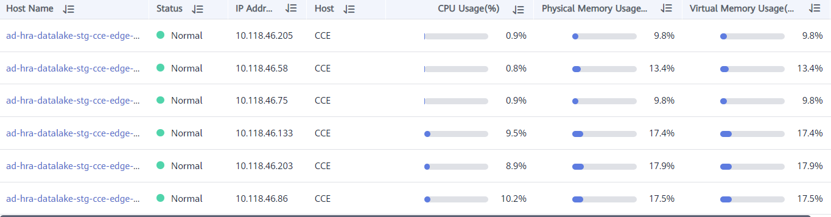

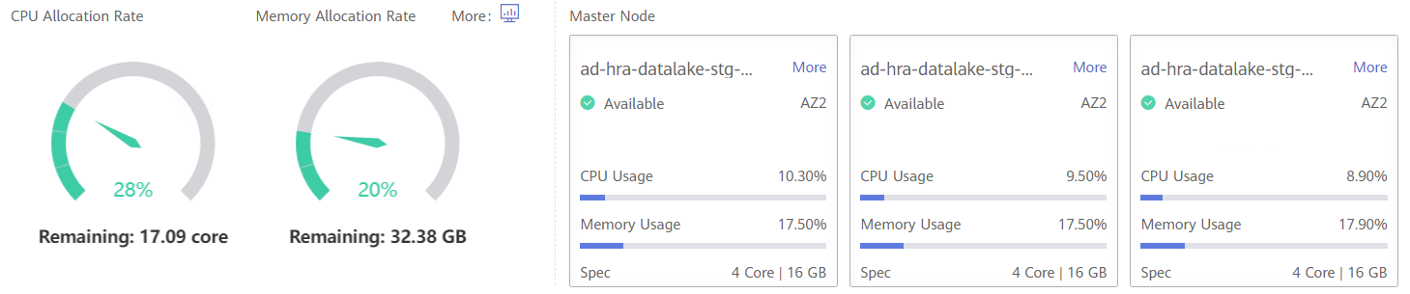



Staging CCE Cluster is healthy and the resource utilization is normal

# Disk usage by hosts

**Production**

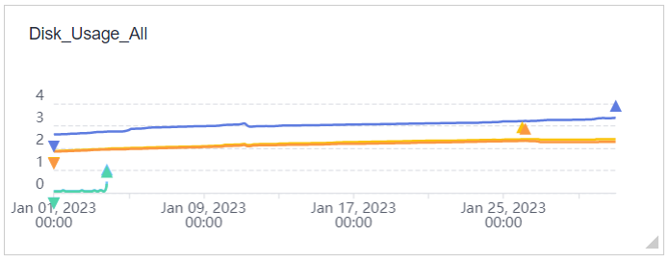



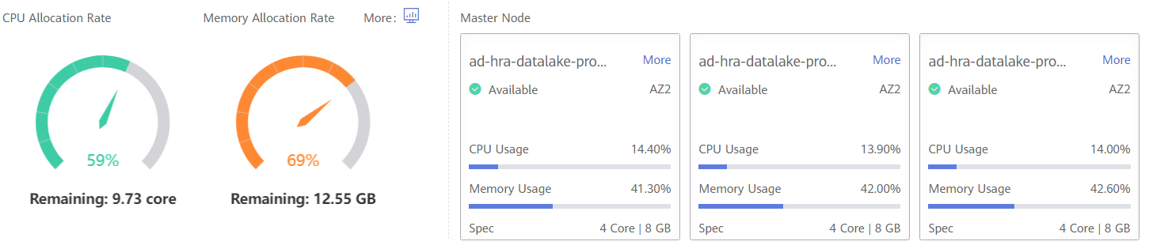

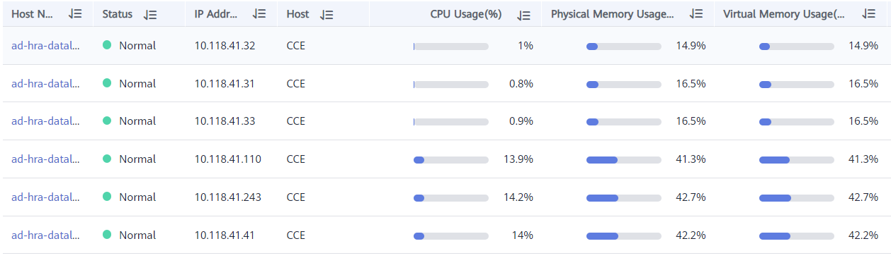



Disk usage is normal in all the hosts and Tableau server Disk usage is under average quota.

# Network bandwidth

**Production**

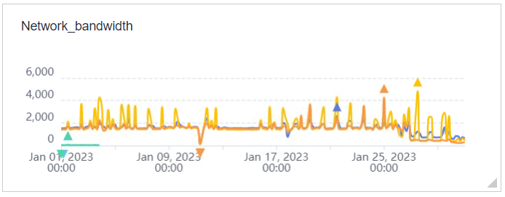





No heavy network usage during the past week in the production environemnt.

# Tickets

**Number of Tickets Created and Resolved this Month**

# 

# Incidents

**Incident Description:** At [27/01/2023 6 AM UAE Time], an issue was reported with the HRA Tableau cluster, resulting in a complete outage.

The issue was determined to be related to Tableau Licensing service failure on the worker the nodes in the cluster. This failure impacted all services running on the affected node and resulted in a complete cluster outage.

**Action Taken:** Our managed services team immediately started working on restoring the cluster with Tableau Support. The first step was to fix the licensing issue by troubleshooting the licensing service and the attempt was failed. As a recovery solution we immediately isolate the affected node and disabled the TSM services from the cluster. This allowed us to bring up the cluster and restore service to bring the business as usual.

# Conclusion

## Highlights

* + All the cloud user access requests have been provisioned by managed services after getting business approvals from HRA.
  + Security patches have been applied to the servers to remediate the vulnerabilities captured by G42 security team.
  + The managed services team has successfully restored the Tableau cluster after the incident. The ongoing Tableau worker node service recovery maintenance plan will ensure that the cluster remains stable by enabling the TSM services in all the worker nodes to recover the cluster to its previous state.
  + managed services team will continue to monitor the Tableau server and take any necessary actions to ensure that the Tableau server remains stable.
  + Tableau was running in a single cluster in production, which makes it difficult to troubleshoot the above-mentioned incident. We have created another cluster under the staging environment in collaboration with Tableau support as a way forward to troubleshoot the issue and test other upcoming Tableau upgrades and patches.

Improvements

* N/A

## Blockers

* N/A



**Thank You**

# 

